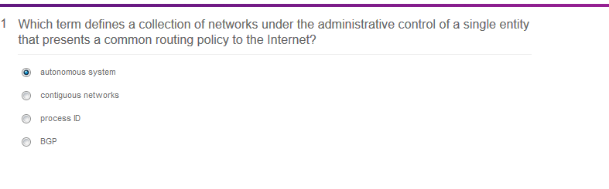

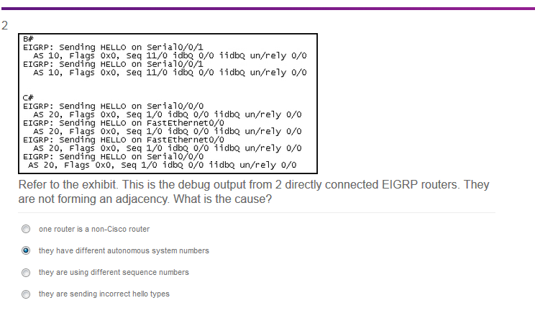

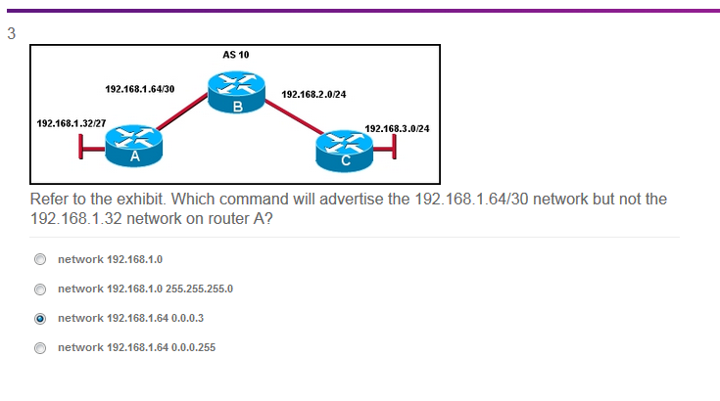

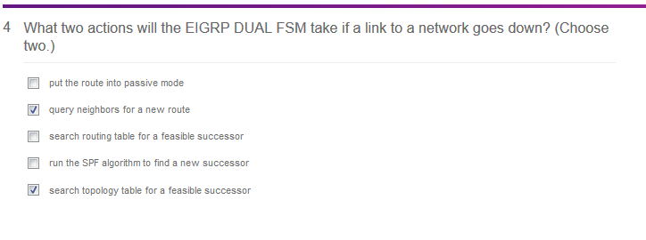

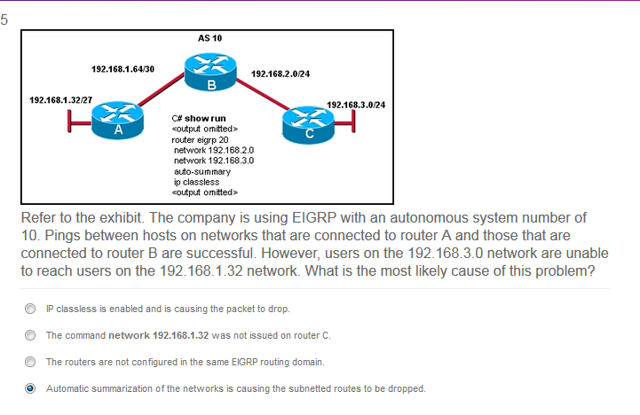

INCORRECT

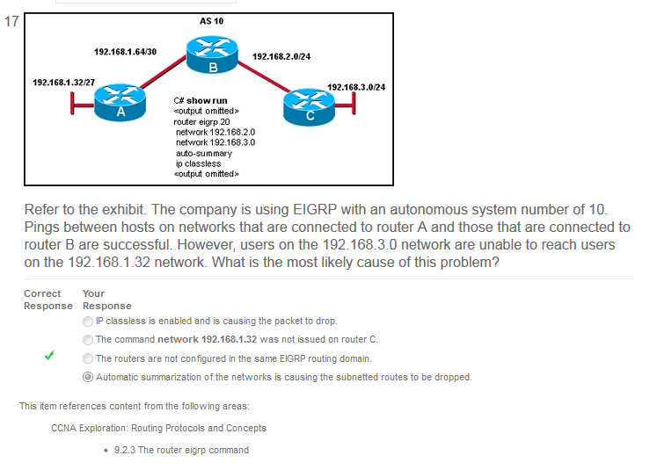

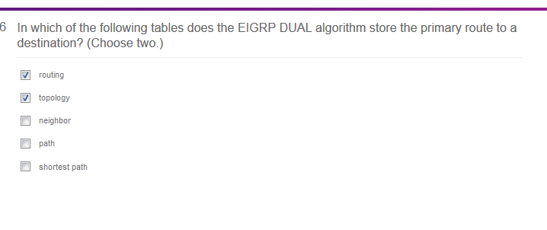

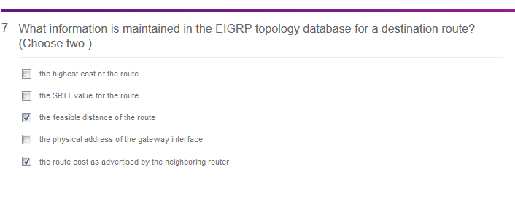

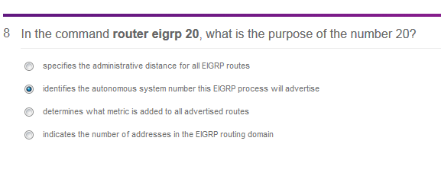

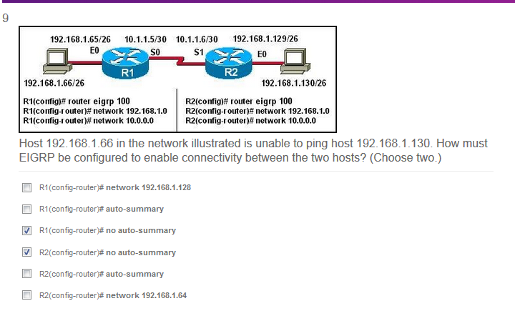

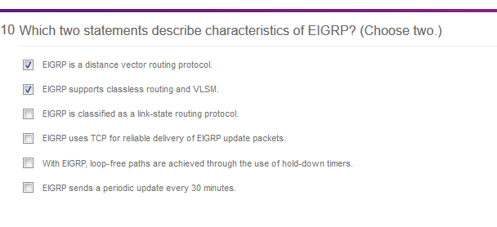

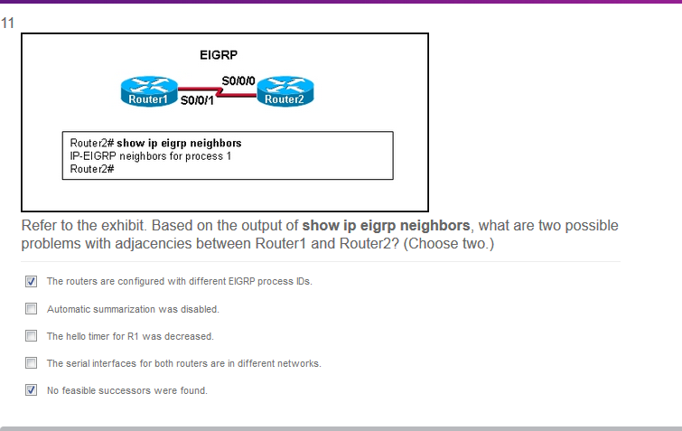

INCORRECT:

**21**.

[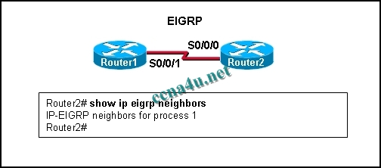](http://answers.ccna4u.net/wp-content/uploads/2011/02/1131.jpg)

**Refer to the exhibit. Based on the output of show ip eigrp neighbors, what are two possible problems with adjacencies between Router1 and Router2? (Choose two.)**  
The routers are configured with different EIGRP process IDs.  
Automatic summarization was disabled.  
The hello timer for R1 was altered.  
The serial interfaces for both routers are in different networks.  
No feasible successors were found.

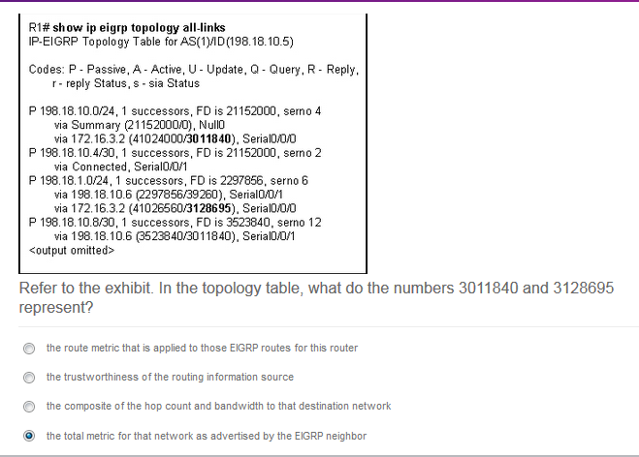

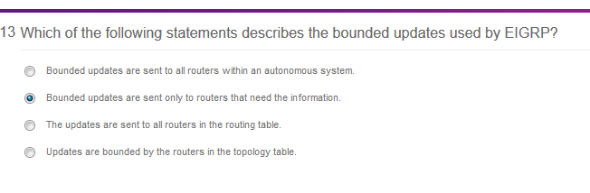

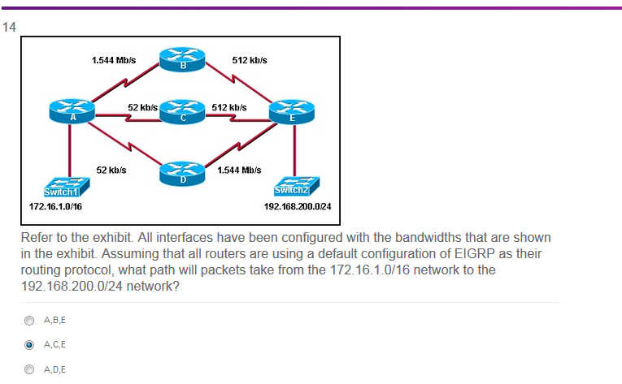



INCORRECT:

**17**.

[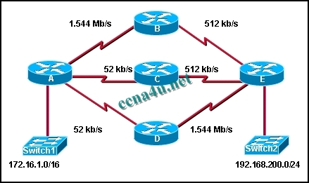](http://answers.ccna4u.net/wp-content/uploads/2011/02/1421.jpg)

**Refer to the exhibit. All interfaces have been configured with the bandwidths that are shown in the exhibit. Assuming that all routers are using a default configuration of EIGRP as their routing protocol, what path will packets take from the 172.16.1.0/16 network to the 192.168.200.0/24 network?**  
A,B,E  
A,C,E  
A,D,E  
Packets will load balance across the A,B,E and A,C,E paths.  
Packets will load balance across the A,B,E and A,D,E paths.  
Packets will load balance across the A,C,E and A,D,E paths.

NOTE: MB is bigger than KB

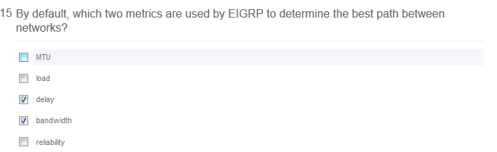

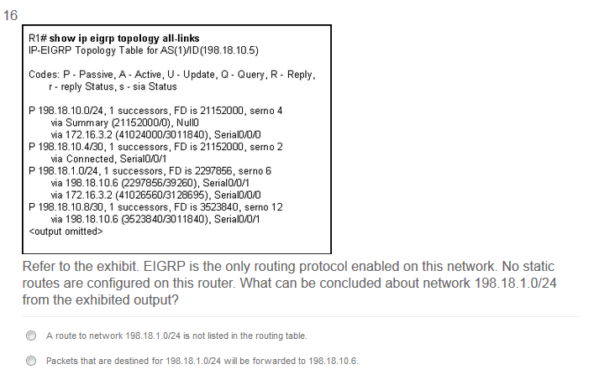

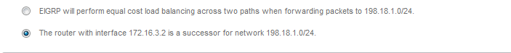

INCORRECT:

[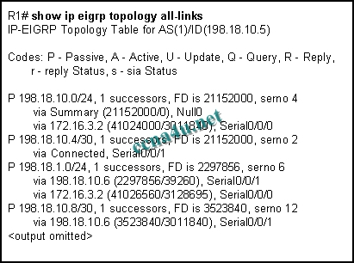](http://answers.ccna4u.net/wp-content/uploads/2011/02/133.jpg)

**Refer to the exhibit. EIGRP is the only routing protocol enabled on this network. No static routes are configured on this router. What can be concluded about network 198.18.1.0/24 from the exhibited output?**  
A route to network 198.18.1.0/24 is not listed in the routing table.  
Packets that are destined for 198.18.1.0/24 will be forwarded to 198.18.10.6.  
EIGRP will perform equal cost load balancing across two paths when forwarding packets to 198.18.1.0/24.  
The router with interface 172.16.3.2 is a successor for network 198.18.1.0/24.

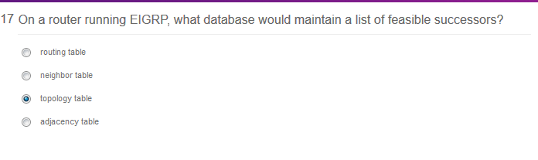

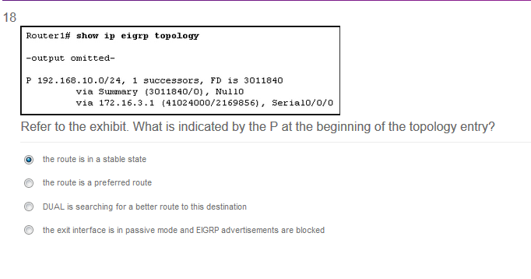

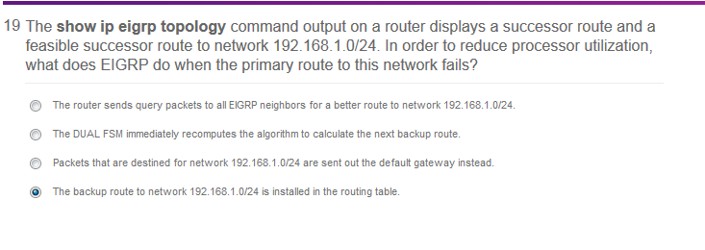

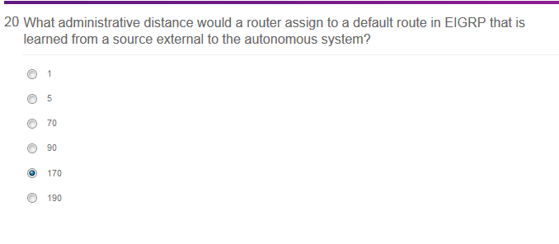

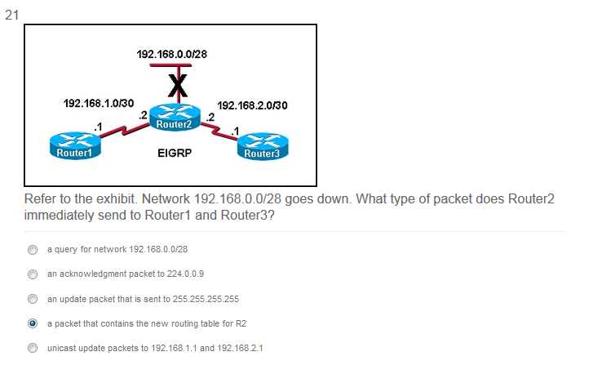

INCORRECT:

